For a php session to exist on the next page during a redirect, upload_tmp_dir and session.save_path have to have the same path as displayed below. If they are not the same, the session won’t stay logged in because your program will be looking in the wrong directory and then quickly give up; indicate an empty session and redirect to your login.

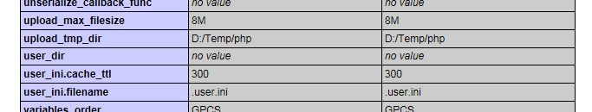

Figure upload_tmp_dir in "Core"



Figure 2 session.save_path in "Sessions"

The paths are the same on the left side because I included a **.user.ini** file in the root directory on my server which includes this line: **session.save_path = D:/Temp/php** Otherwise, the left “local” side would display D:\Temp\php\session\ ; e.g., if I removed the .user.ini file from my server.

To fix the problem:

* open wordpad
* type in the session.save_path = whatever is in the upload_tmp_dir
* call it “.user” and save it as an MS ini file (or just type in .user.ini and hit save)
* upload the file into your root directory on your server
* test for effect

Godaddy offers an option to use a php5.ini file which can configure the upload temp directory as well. <http://php.net/manual/en/configuration.file.php> I’ve heard it is a good practice to have quick access to these temp files to check on your sessions and whether they are piling up in there (bad) or being unset when unused (good). This didn’t work for me. However, I am satisfied with the user.ini fix. I hope you enjoy this solution because after three calls to their server help folks, I am pretty sure there is no other until they change their code. Aloha!